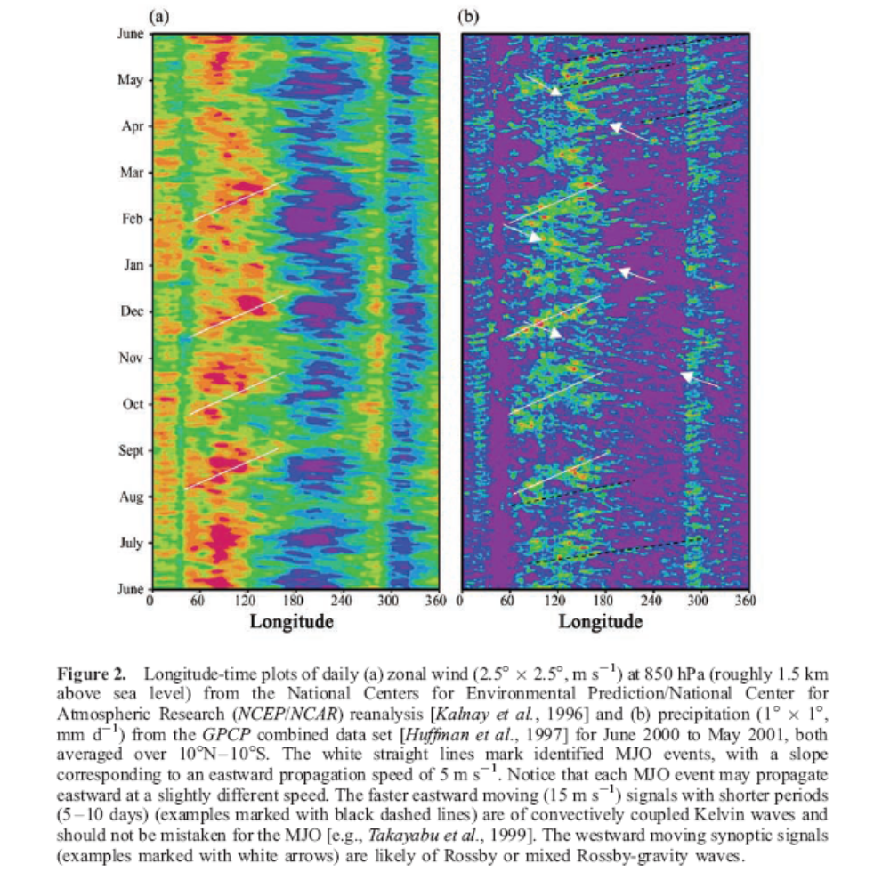

From: Madden-Julian Oscillation by Chidong Zhang
[ Reviews of Geophysics, 43, RG 2003/2005]
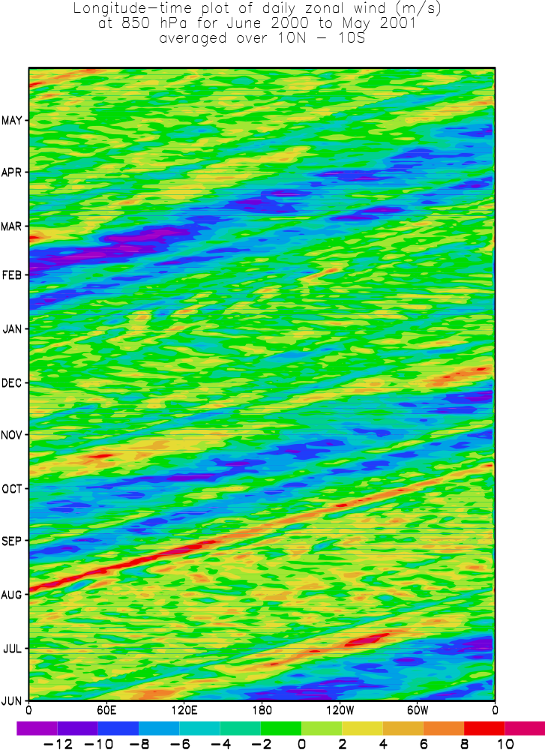

Generated from GrADS

* To investigate MJO based on 850 hPa zonal wind
* by Ooi See Hai on 21 September 2006
*
'reinit'
*
'sdfopen g:\cdc\uvw\uwnd.2000.nc'
'sdfopen g:\cdc\uvw\vwnd.2000.nc'
'sdfopen g:\cdc\uvw\uwnd.2001.nc'
'sdfopen g:\cdc\uvw\vwnd.2001.nc'
'set gxout fwrite'
'set fwrite c:\mjo\data\zhang.dat'
*
'set lev 850'
*
m=609
while (m <= 2068)
'set t 'm
if (m <= 1464)
'd ave(uwnd,lat=-10,lat=10)'
'd ave(vwnd.2,lat=-10,lat=10)'
else
'd ave(uwnd.3,lat=-10,lat=10)'
'd ave(vwnd.4,lat=-10,lat=10)'
endif
m=m+4
endwhile
*
*
'disable fwrite'
*
'reinit'
*
* To plot zonal wind
* ------------------
*
'open c:\mjo\ctl\zhang.ctl'
*
'set grads off'
'set parea 1.0 7.0 1.0 10.0'

*
'set lon 0 360'
'set t 1 365'
'set tlsupp year'
*
'set gxout shaded'
'set csmooth on'
'set cint 2'
'd u'
'run cbar'
*
'set annot 1 2'
'draw title Longitude-time plot of daily zonal wind (m/s) \ at 850 hPa for June 2000 to May 2001 \ averaged over 10N - 10S\ '
'enable print c:\mjo\product\zhang.gmf'
'print'
'disable print'
*

dset c:\mjo\data\zhang.dat
undef -9.99e+33
title 00 Z 850 hPa u- component winds
from 1 Jun 2000 2000 to 31 May 2001
averaged between 10S and 10N
xdef 144 linear 0 2.5
ydef 1 linear 1 1
zdef 0 linear 0 0
tdef 365 linear 1jun2000 1dy
vars 2
u 0 99 1 u-wind [m/s]
v 0 99 1 v-wind [m/s]
endvars

